Task 3 (**Back-Propagation learning algorithm**) Report

* Plenty of Trials including the best accuracy obtained:

|  |  |  |  |  |  |  |
| --- | --- | --- | --- | --- | --- | --- |
| **Activation Function** | **Test Accuracy (%)** | **Learning Rate (eta)** | **Number of Epochs** | **Number of Hidden Layers** | **Neurons in each Hidden Layer** | **Adding Extra Weight (Bias)** |
| Sigmoid | 33.33 | 0.00001 | 20 | 6 | 5, 5, 5, 5, 5, 3 |  |
| Hyperbolic Tangent | 33.33 | 0.0001 | 10 | 2 | 2, 3 |  |
| Sigmoid | 33.33 | 0.00001 | 10 | 3 | 5, 5, 5 | C:\Users\Eng_Kareem\AppData\Local\Microsoft\Windows\INetCache\Content.Word\Done2.png |
| Sigmoid | 35 | 0.001 | 30 | 5 | 7, 7, 7, 7, 7 | C:\Users\Eng_Kareem\AppData\Local\Microsoft\Windows\INetCache\Content.Word\Done2.png |
| Hyperbolic Tangent | **80.00** | 0.0001 | 30 | 3 | 5, 5, 5 |  |

* **Hyperbolic Tangent**

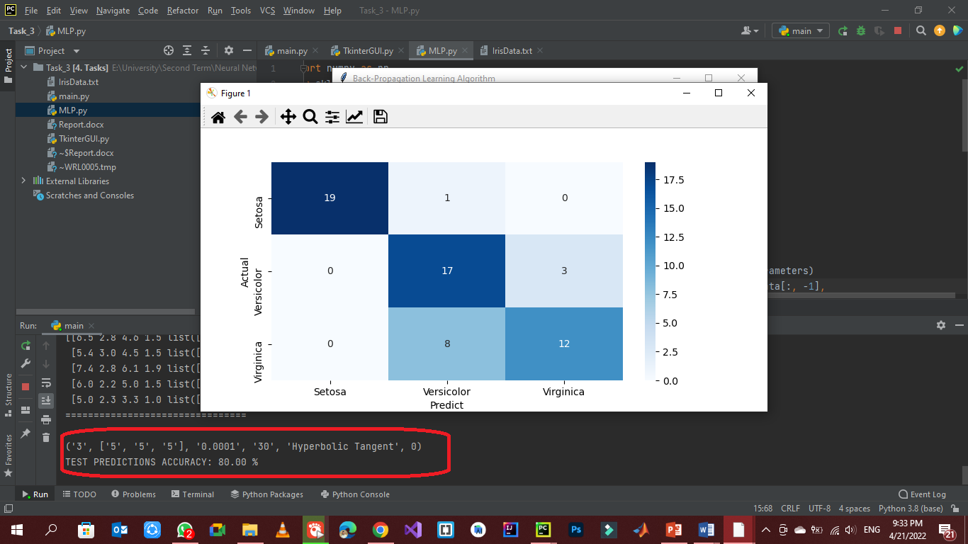

* **Sigmoid**

**